**1. New project ExploreGIS**

Screenshot:



**2. Geographic area**

Root River (Wisconsin)

[42.7335°N 87.7785°W](https://geohack.toolforge.org/geohack.php?pagename=Root_River_(Wisconsin)&params=42.7335_N_87.7785_W_source:wikidata-and-enwiki-cat-tree_region:US)

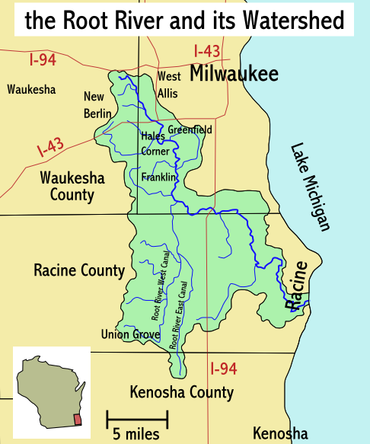

**3. Create a map**

Screenshot:

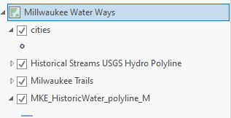

**4. Search mgisdata folder**

DataSets:

USA (Rivers)

USA (Lakes)

USA (Cities)

Screenshot:

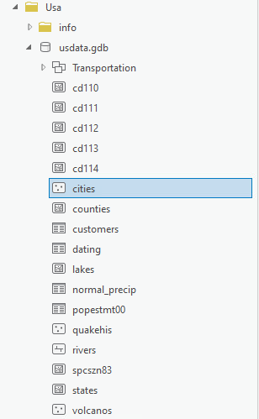

**5. Search ArcGIS Online**

Data Sets:

[Milwaukee Trails](https://www.arcgis.com/home/item.html?id=f674f977aaa242a0ad9941746ec07c51#)

[MKE_HistoricWater_polyline_merge](https://www.arcgis.com/home/item.html?id=7ade03583f4d424a82ae9ffe4383495e)

[MKE_HistoricWater_polygon_MM_WebAux_TP](https://www.arcgis.com/home/item.html?id=78feedea1fca47f4a11dab2c1f1a82ed)

[Lake Michigan Shoreline](https://www.arcgis.com/home/item.html?id=f45fe24190114923a4127b9483855196#)

[Lake Michigan Bathymetric Contours](https://www.arcgis.com/home/item.html?id=5b75b359e7614283aeca6c72d8e97e01#)

[Historical Streams USGS Hydro Polyline](https://www.arcgis.com/home/item.html?id=6bc595580aa04b4b81c221f6cde95cdf#)

Screenshot:

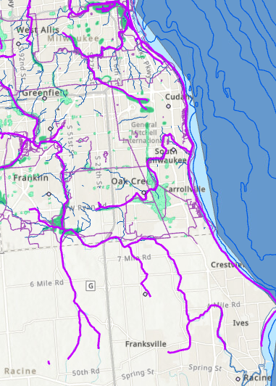

Screenshot: (Root River Parkway Pond) This forested area is what I was specifically interested in however Root River is rather large and Milwaukee had the most data

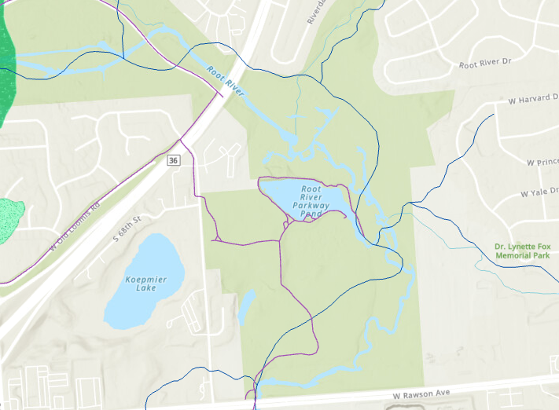

References

Fay2. (2006, February 25). *Root River and its watershed* [Map]. Wikimedia.<https://en.wikipedia.org/wiki/Root_River_%28Wisconsin%29#/media/File:Root_River_WI_map.png>

Federal_User_Community. (2023, May 4). *Lake Michigan Bathymetric Contours*. ArcGIS Online.<https://www.arcgis.com/home/item.html?id=5b75b359e7614283aeca6c72d8e97e01>

Hwhidden_prof_services. (2021, June 18). *Milwaukee Trails*. ArcGIS Online.<https://www.arcgis.com/home/item.html?id=f674f977aaa242a0ad9941746ec07c51>

LawrenceGWMKE. (2021, November 22). *MKE_HistoricWater_polyline_merge*. ArcGIS Online.<https://www.arcgis.com/home/item.html?id=7ade03583f4d424a82ae9ffe4383495e>

LawrenceGWMKE. (2022, May 13). *MKE_HistoricWater_polygon_MM_WebAux_TP*. ArcGIS Online.<https://www.arcgis.com/home/item.html?id=78feedea1fca47f4a11dab2c1f1a82ed>

MichiganDNR. (2022, August 16). *Lake Michigan Shoreline*. ArcGIS Online.<https://www.arcgis.com/home/item.html?id=f45fe24190114923a4127b9483855196>

MMSD_GIS. (2021, August 3). *Historical Streams USGS Hydro Polyline*. ArcGIS Online.<https://www.arcgis.com/home/item.html?id=6bc595580aa04b4b81c221f6cde95cdf>